OFFICIAL-SENSITIVE PERSONAL (When Completed) | AFB 203A  (Rev 11/18)
Application for Medical Employment Standards
Waiver on Initial Assignment
Instructions for completing this form
Applicants who have completed ,or will soon complete Initial Trade Training but do not, or are unlikely to meet the minimum medical standard of MFD
A4L1M4E2 by In-Service standards at the point of assignment, may be waived into the Fd Army. This will normally only occur where the applicants prognosis indicates that their maximum possible JMES is likely to return to a deployable grade within a reasonable time-frame and they can be employed in their chosen CEG. Where such a prognosis is not apparent applicants are to be discharged in line with extant Medical Employment Policy.

Trained soldiers who are re-trading need only meet the In-Service RETENTION standard of A4L4M4E4 to be assigned to a Fd Army Unit.

The employing training unit is responsible for completing section 1-4 before forwarding this form to ARITC OM Admin (ARITC-OccMed-AFB203@mod.gov.uk) who will progress the application.
Section 1 - Mandatory Personal Details (Completed by all applicants)
First Name(s)
Surname
*
Date of Birth
*
Age
Service Number
Address of Training Unit
Trade or CEG
Current Training Unit
Regular
Reserve
Other Rank (OR)
Re-Trade
Initial Enlistment
Cap Badge
Officer (OF)
Section 2 - Medical Consent - ONLY to be completed by the applicant.
Release of Medical Employment Advice. I give my consent for the military Chain of Command to access my JMES and all appropriate Medical Employment Policy Appendices. I also consent for the appropriate medical personnel (ARITC, LWC, current unit MO and appropriate specialists) to access all personal medical records and provide information regarding my prognosis (Section 3) to the military Chain of Command. Failure to provide this consent will lead to Appendix 21 invaliding action.
Release of Supporting Medical Information. I give my consent for the Occupational Medicine Department at Headquarters Army
Recruiting and Initial Training Command to discuss limited clinical medical in confidence details of my waiver condition(s). I acknowledge that this disclosure will allow the discussion of evidence based decisions on whether or not I am medically fit enough to serve in the Regular or Reserve Army under the provisions of the Application for Medical Employment Waiver on Initial Assignment (AFB203A) authorisation. All personal Data will be processed and managed in line with the extant legislation.
Rank / Grade
Full Name
Telephone Number
Email Address
Signature PUID
Date
Section 3 - Current Medical Grading (All Fields are Mandatory) - to be completed by the attending Medical Officer/Examiner
A
L
M
E
MDS
Perm
Temp
MES:
Date of Award
Date of Review
Current JMES:
- to be completed by unit MO
Other than MFD, has a different JMES been awarded while in the training pipeline?
No
Yes
Suffix:
Prognosis:
- to be completed by unit MO
The applicant’s highest JMES is likely to be:
The applicants will likely obtain this standard in:
MFD
MLD
Perm
A
L
M
E
MND
1
Month
Months
3
6
Months
9
Months
12
Months
>12
Months
* Mandatory Fields
Medical Comments
where applicable, to elaborate on prognosis, medical risk, specific duration required to attain MFD and functional ability
(
to perform within potential role. If specialist occupational medicine/health or functional e.g. weapons handling assessment has been
completed, this should be submitted with the AF B 203A) - Not to include specific clinical information.
Medical Officers Details:
- to be completed by unit MO
Signature PUID
Date
Email Address
Telephone No.
MO Full Name
MO Appointment
MO Rank / Grade
Training Unit Commanding Officer’s Comments
(this should concentrate on the applicants potential in their chosen CEG/Trade, their
attitude towards recovery and any mitigating or supporting evidence for their continued employment in the JMES indicated in Section 2)
Training Unit Commanding Officer’s Comments (this should concentrate on the applicants potential in their chosen CEG/Trade, their attitude
towards recovery and any mitigating or supporting evidence for their continued employment in the JMES indicated in Section 2).
Section 4 -
Sponsorship (All Fields are Mandatory)- to be completed by the attending both Training Unit and Receiving Army Unit Cos/HoEs
Rank / Grade
Full Name
Appointment
Telephone Number
Email Address
Signature PUID
Date
Outcome of physical tests if attempted:
PFA | CSA
PASS
FAIL
N/A
Date
PSS(O)/(R) | RFT-E
PASS
FAIL
N/A
Date
AFT | RFT-S/A
PASS
FAIL
N/A
Date
Progression through Trg Pathway,
weeks of a total
Date of Commission/ Passing Out
Employing/Receiving Commanding Officer
(by agreeing to sponsor this applicant you confirm that you are able to employ them in their
current Trade/CEG within the remit of their indicated JMES while facilitating their recovery pathway. Furthermore you are agree to manage
the individual inline with current policy summarised in Section 8. It is essential that you incorporate adequate detail of the applicants
proposed employment for an occupational medical recommendation to be offered, as a minimum this must include; proposed duties and
responsibilities, proposed hours and patterns of work; the precise proposed role and location, any special requirements of the proposed role.
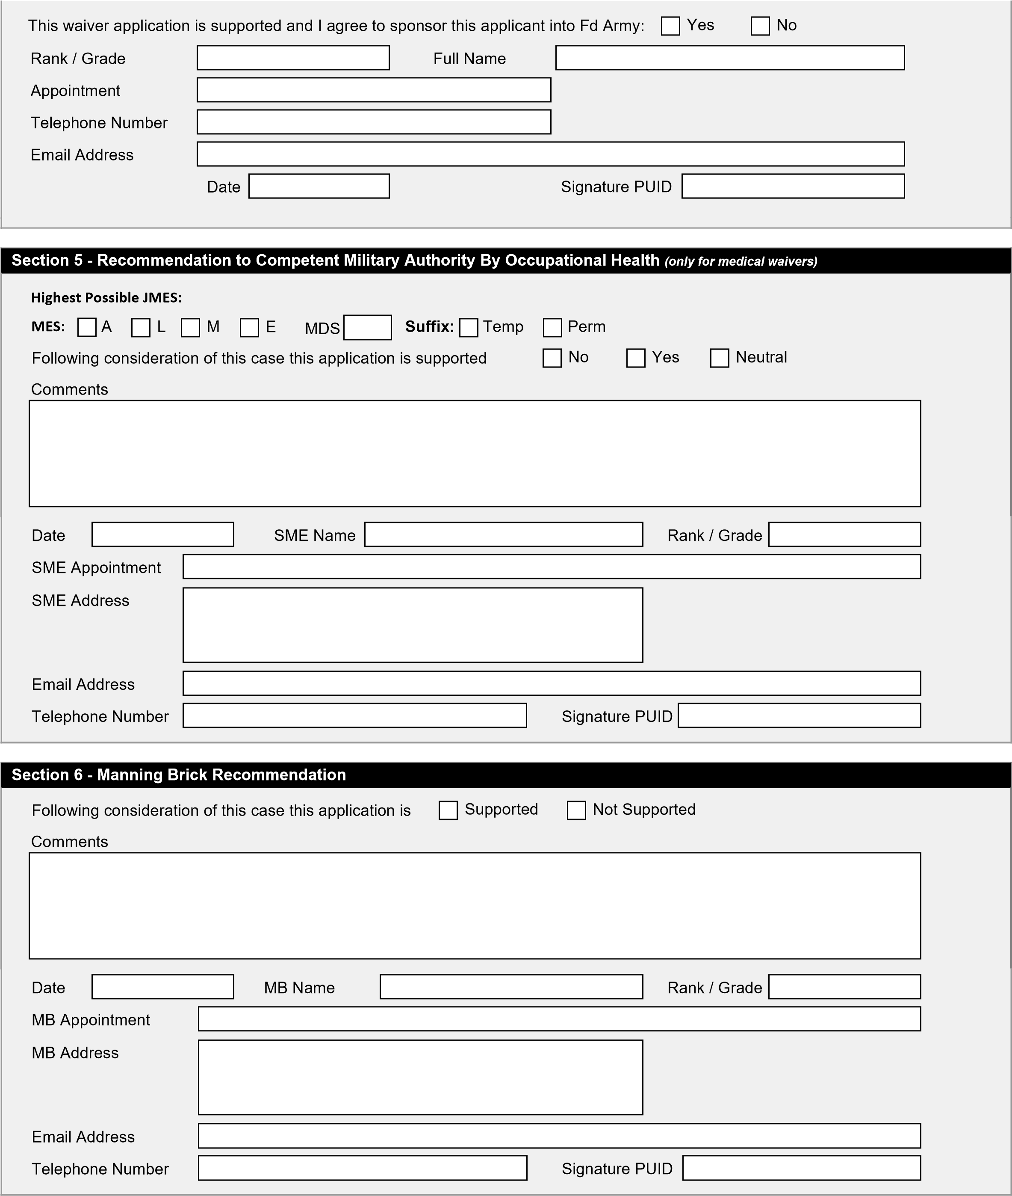
Section 7 - Competent Military Authority Decision
Details of the Competent Military Authority can be obtained from AGAI 40 and Medical Employment Policy. Department of Manning (Army)
DM(A)) Employment Policy is the Competent Military Authority for the AFB203A.
(
Policy Reference
Comments
Following consideration of this case this application is
Endorsed
Rejected
Date
CMA Name
Rank / Grade
CMA Appointment
Email Address
CMA Address
Telephone Number
Signature PUID

Section 8 - Mandatory Employment Responsibilities
DM(A) have authorised an applicant to be assigned to your Field Army unit in a grade below the minimum required Joint Medical Employment Standard of A4L1M4E2 MFD.

MLD
It is essential that once the applicant has joined the unit they are reviewed by the unit Medical Officer and receive an in propria persona medical grading and updated Appendix 9, a copy of this AF B203A MUST be forwarded to the medical officer and uploaded to DMICP during this review. The unit must complete (and keep up to date) an Appendix 18 explaining how they will be managed and their condition will be mitigated while in the unit. The unit will also need to complete an Appendix 27 (Unit Implications Brief) to ensure that the applicant understands the limitations their condition may have on their career.

If at any point the applicant is downgraded to A4L5M4E5 MND, then the unit will need to comply with extant medical employment policy and either start the invaliding process or apply for their retention on an Appendix 8.

Unless stated otherwise in policy all appendices should be created and uploaded to PAPMIS, as should a copy of this AFB203A.

MND
In extremis where a recovery pathway to an employable grade is quantifiable DM(A) may authorise an application for medical waiver on initial assignment in an L5 grade.

It is essential that once the applicant has joined the unit they are reviewed by the unit Medical Officer and receive an in propria persona medical grading and updated Appendix 9, a copy of this AFB203A MUST be forwarded to the medical officer and uploaded to DMICP during this review. The unit must complete (and keep up to date) an Appendix 18 explaining how they will be managed and their condition will be mitigated while in the unit. The unit will also need to complete an Appendix 27 (Unit Implications Brief) to ensure that the applicant understands the limitations their condition may have on their career.

In these circumstances the AFB203A authorises the retention of the candidate in lieu of an Appendix 8 for a period of 2 years or on subsequent assignment, whichever occurs first. As such it is essential that the AFB203A is uploaded to PAPMIS and all mandatory appendices are also created in this fashion unless directed otherwise by policy. In the unlikely event that the individual has not been subsequently upgraded to a grade within the retention standard, the unit must apply for their further retention on an Appendix 8 on PAPMIS.

If at any point the applicant is graded L6E5 MND then they will need to be discharged in line with the Medical Board’s recommendation, concurrently an application can be made to the Army Employment Board for their retention.

Terminology
Likelihood of an outcome or result
"Virtually certain" means greater than a 99 percent probability of occurrence.
"Extremely likely" means greater than 95 percent.
"Very likely" means greater than 90 percent.
"Likely" means greater than 66 percent.
"More likely than not" means greater than 50 percent.
"About as likely as not" means 33 to 66 percent.
"Unlikely" means less than 33 percent.
"Very unlikely" means less than 10 percent.
"Extremely unlikely" means less than 5 percent.
"Exceptionally unlikely" means less than 1 percent.

Relative degrees of confidence in a statement
"Very high confidence" means at least a 9 out of 10 chance of being correct.
"High confidence" means about an 8 out of 10 chance.
"Medium confidence" means about a 5 out of 10 chance.
"Low confidence" means about a 2 out of 10 chance. "Very low confidence" means less than a 1 out of 10 chance.

